**Advance Excel Assignment 5**

1. How many types of conditions are available in conditional formatting on Excel?

There are three basic conditions are available in conditional formatting.

* Greater than
* Less than
* Equal

There are five different conditions are available in custom conditional formatting.

* Greater than
* Less than
* Equal
* Greater than or Equal
* Less than or Equal

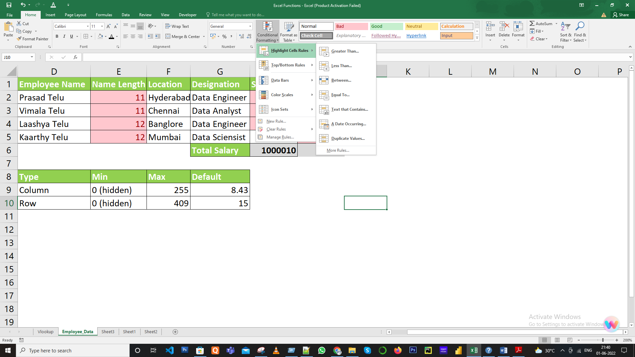

1. How to insert border in Excel with Format Cells dialog?

To insert a border via the Format Cells dialog, this is what you need to do:

1. Select one or more cells to which you'd like to add borders.

2. Open the Format Cells dialog box by doing one of the following:

* Click the down arrow next to the Borders button, and then click More Borders at the bottom of the drop-down list.
* Right-click the selected cells and choose Format Cells… from the context menu.
* Press Ctrl+1 shortcut.

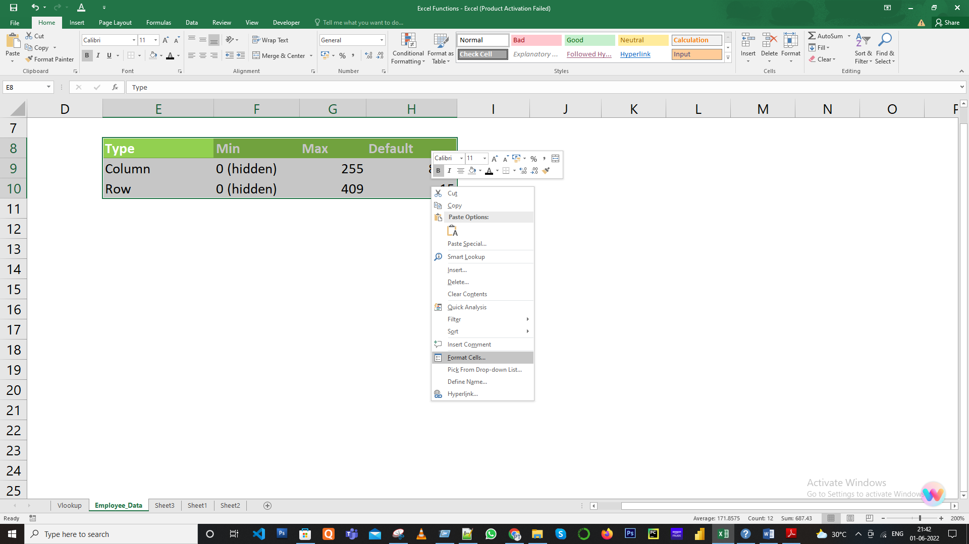

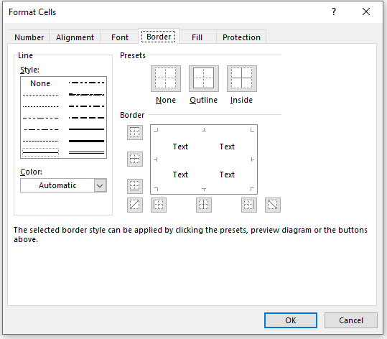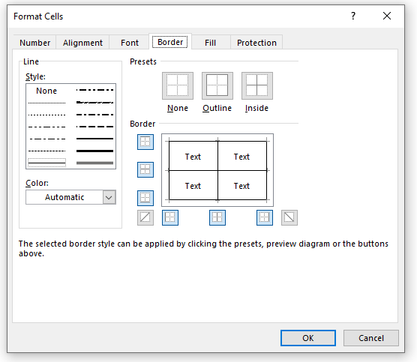

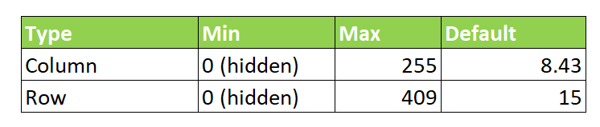

1. How to Format Numbers as Currency in Excel?

* Select the cells that you want to format
* Right click on the selected Cells and select Format Cells
* Format Cells dialog pop-up should be displayed
* By default, the format is in General category, change to Currency
* Check the currency symbol and decimal values and Click Ok

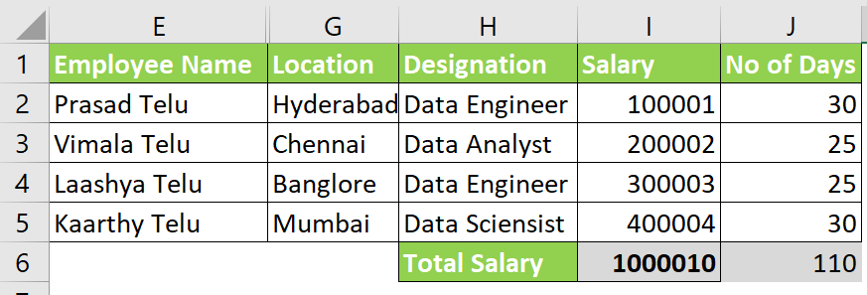

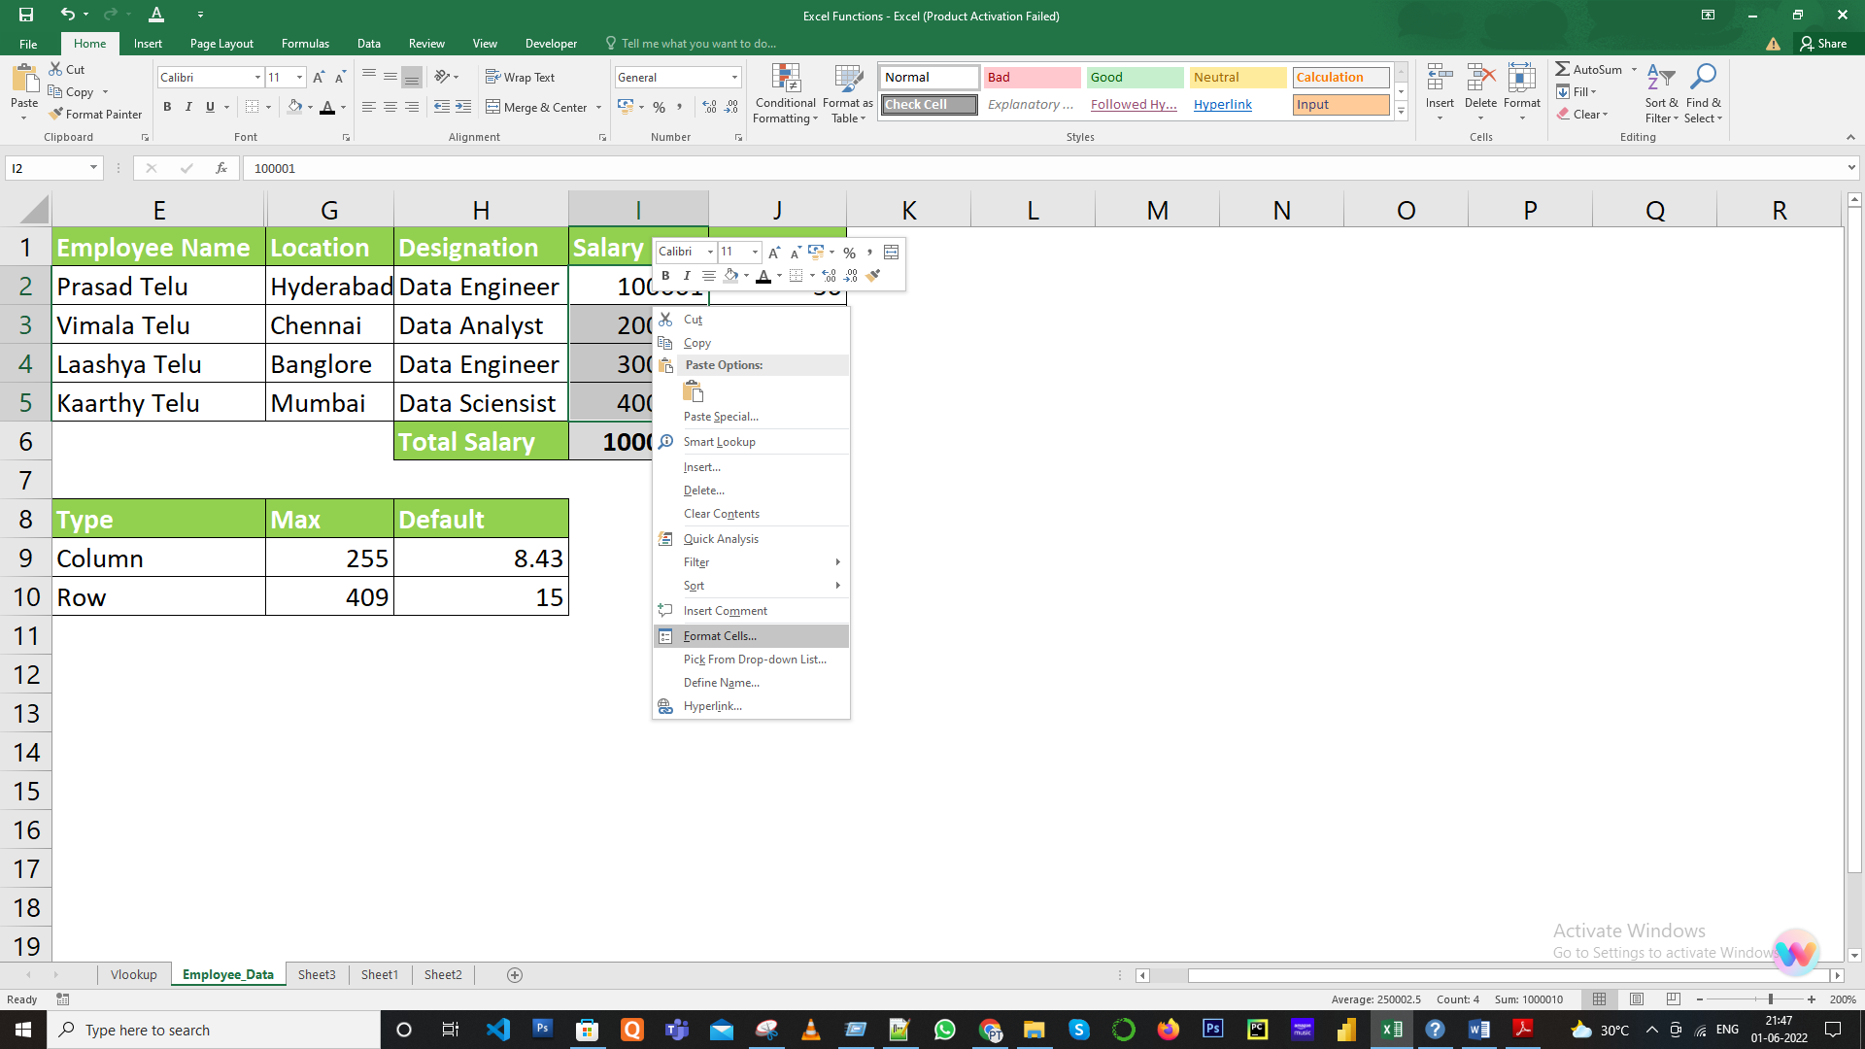

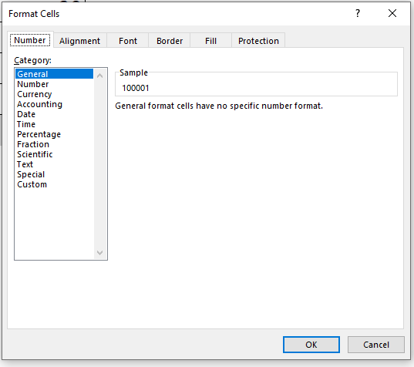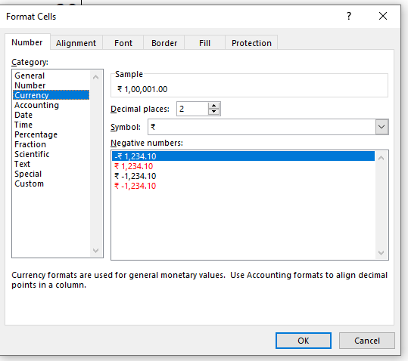

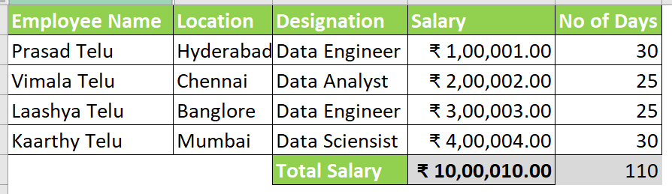

1. What are the steps to format numbers in Excel with the Percent style?

**Solution:**

* Select the number column

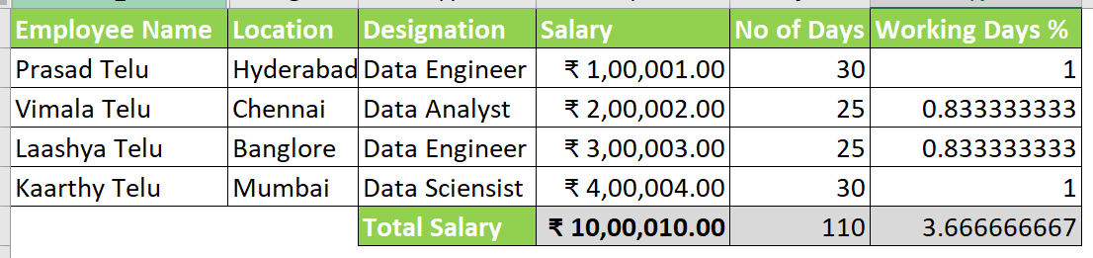

Right-click on the numbers column and select Format Cells. By default, it will be in General category and change to percentage.

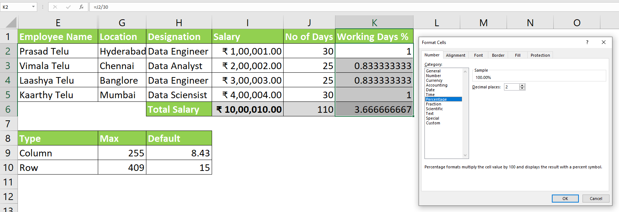

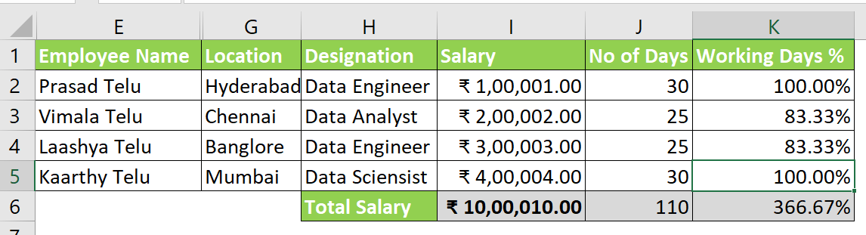

1. What is a shortcut to merge two or more cells in excel?

**Shortcut: ALT H+M+M**

**Note:** When you merge multiple cells, the contents of only one cell (the upper-left cell for left-to-right languages, or the upper-right cell for right-to-left languages) appear in the merged cell. The contents of the other cells that you merge are deleted.

1. How do you use text commands in Excel?

The TEXT function is invaluable because it allows you to force Excel to format the values the way you want by using a format code, like "MM/DD/YY" for date format.

**Syntax:** TEXT(value, format_text)

